**HW1- CSE 291: Pattern Recognition**

**Ronit Shaw A53220859**

**Sumedha Khatter A53094878**

**Wine Data Set**

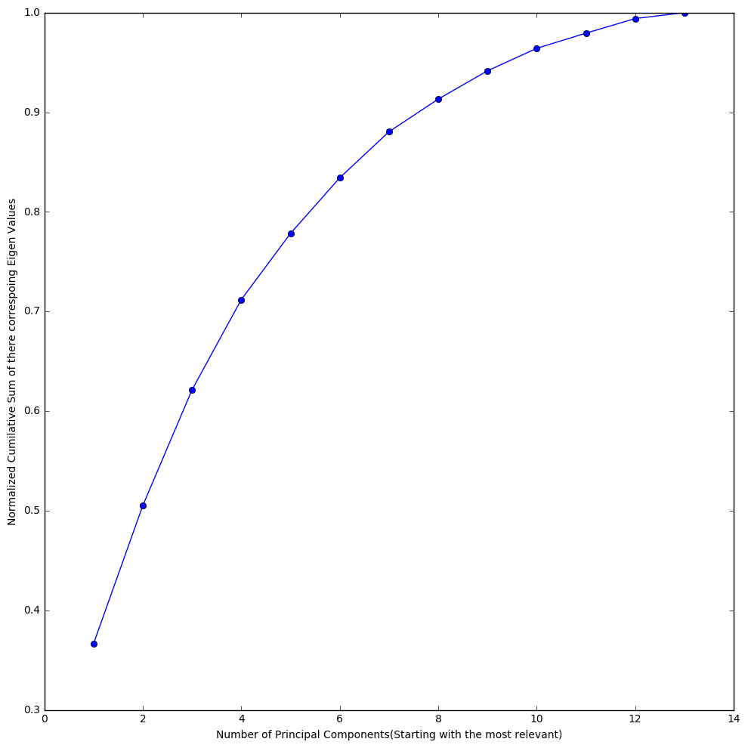

**Plot of Normalized Cumilative Sum of Eigen Values vs Number of Corresponding Principal Components used (Stasting with the Most relevant one)**

**From the Graphs Choosing , We decided to go ahead with 7 Prinicpal Components as It lies in the Knee Region of the graph and explains most of the variance in the data. The remaining Components do not explain much of the variance in the data**

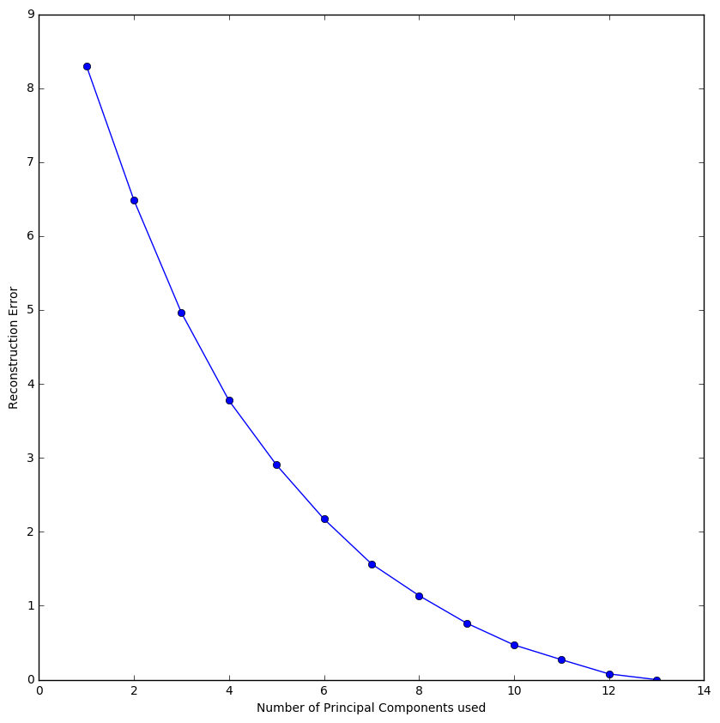

**Plot of Reconstruction Error Vs Number of Principal Components Used**

**MNIST Data Set**

**“0-1 Classification”**

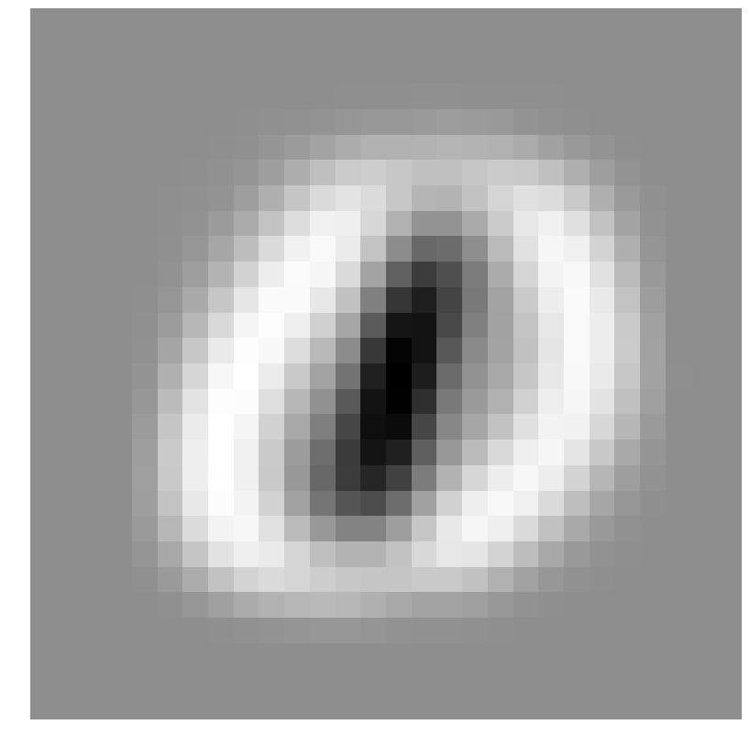

**Most Important Eigen Vector**

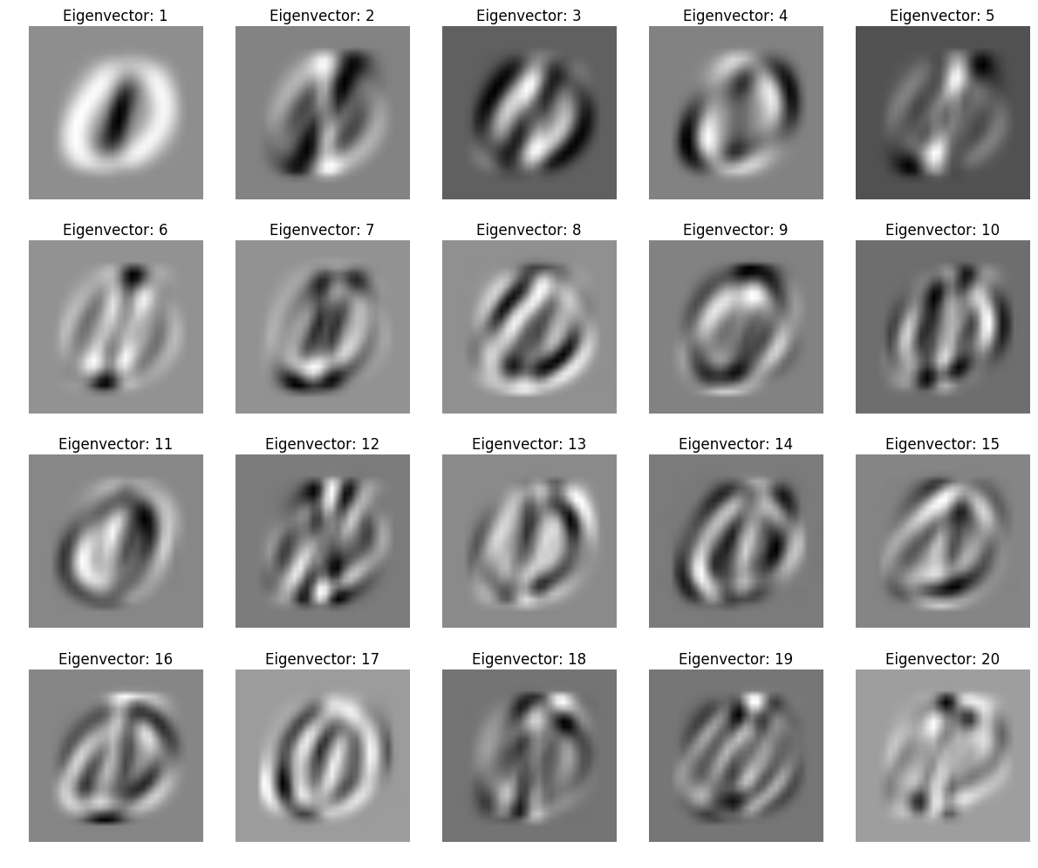

**Top 20 most important Eigen Vectors**

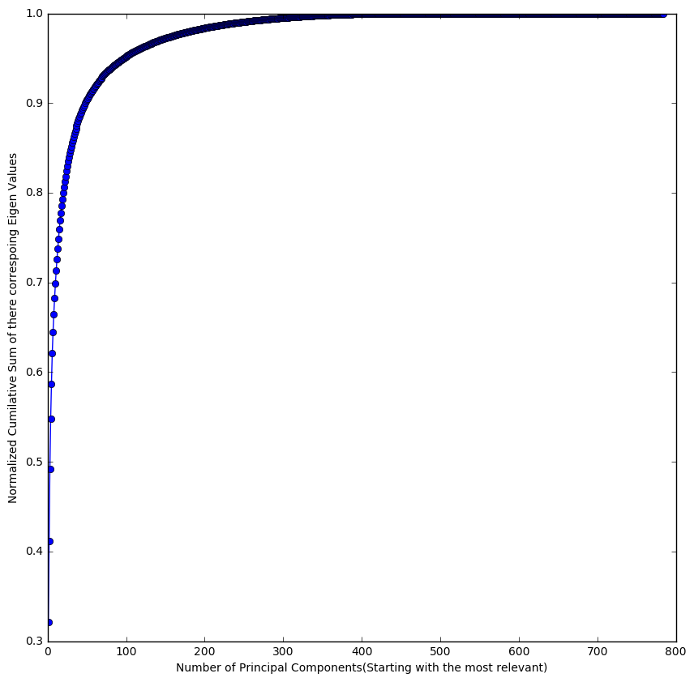

**Plot of Normalized Cumilative Sum of Eigen Values vs Number of Corresponding Principal Components used (Stasting with the Most relevant one)**

From the Graph, choosing a point from the Knee region of the Graph 50 Principal Components was chosen as those 50 explain more than 90% of the variance in the data

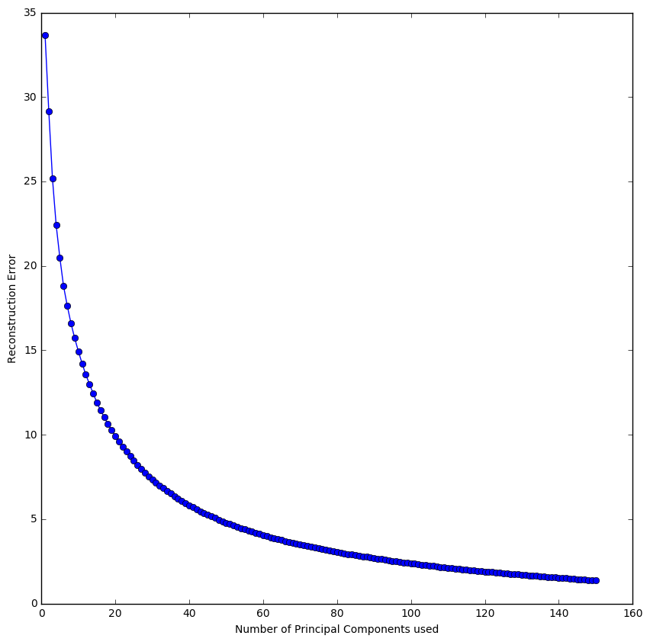

**Plot of Reconstruction Error Vs Number of Principal Components Used**

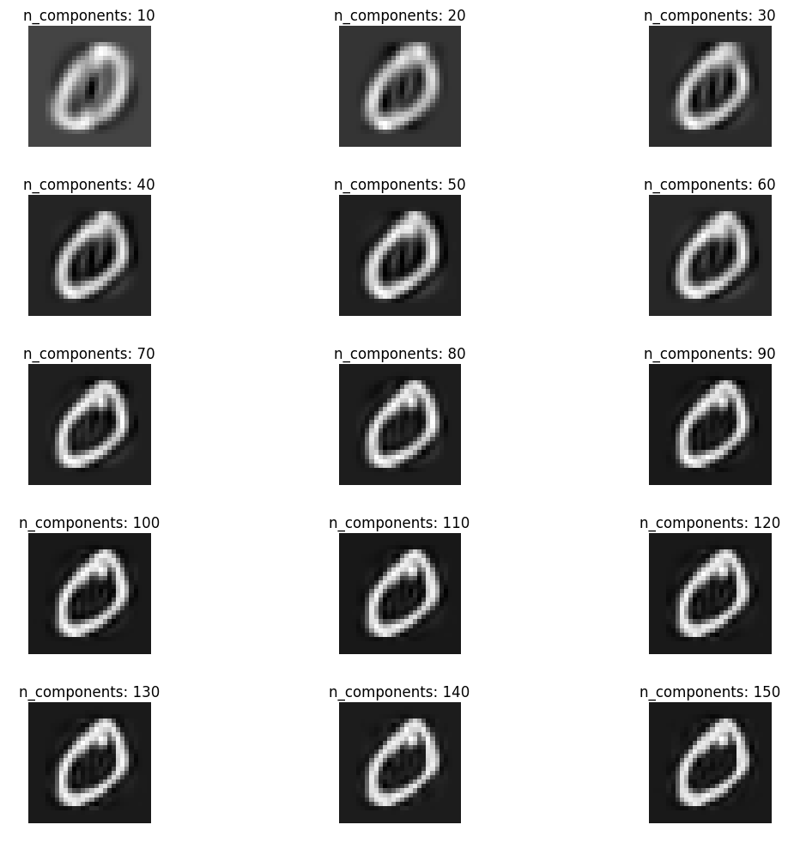

**Visualization of Reconstruction using different number of Principal Components**

**“3-5 Classification”**

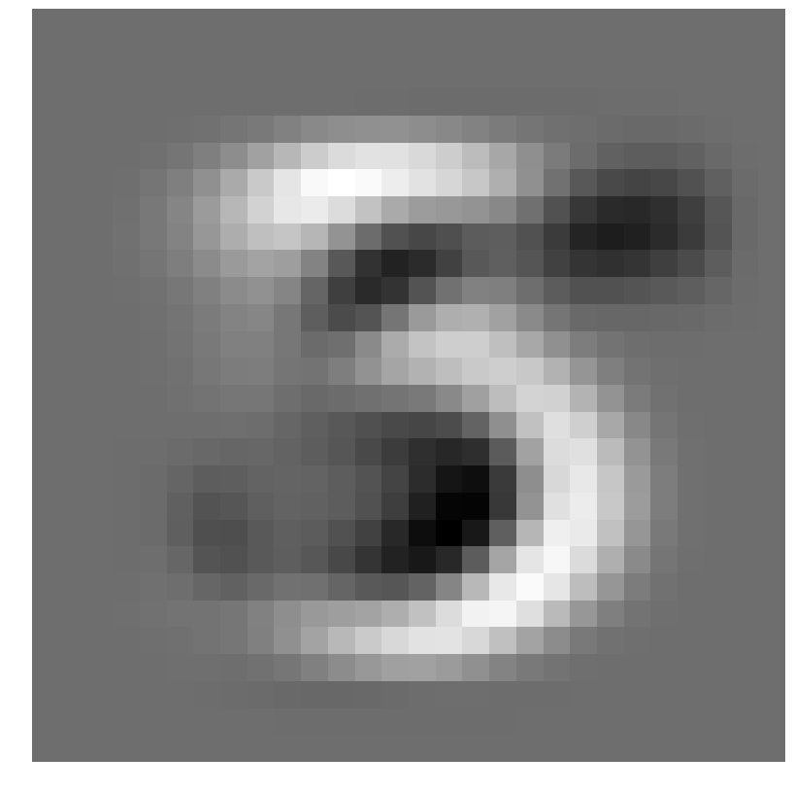

**Most Important Eigen Vector**

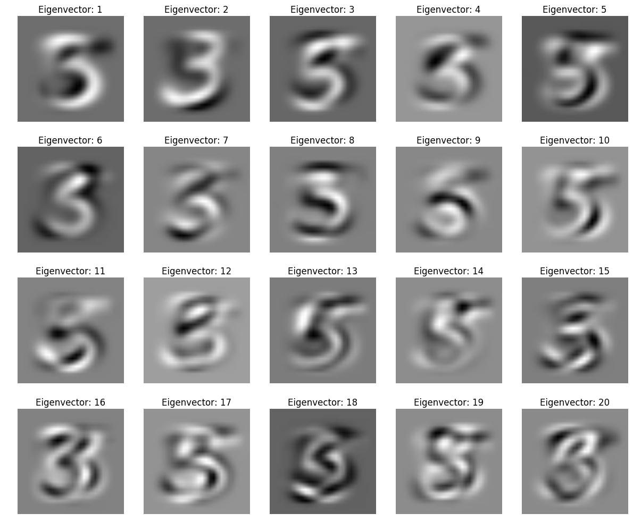

**Top 20 Most Important Eigen Vectors**

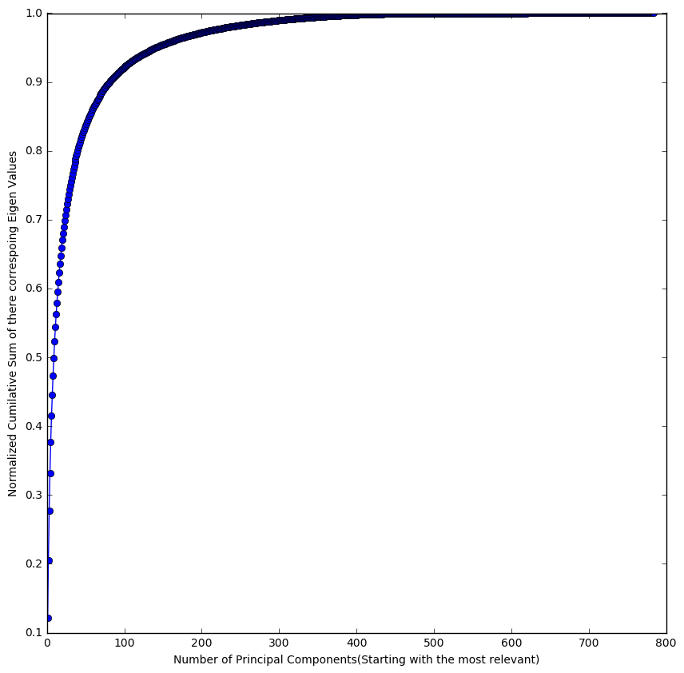

**Plot of Normalized Cumilative Sum of Eigen Values vs Number of Corresponding Principal Components used (Stasting with the Most relevant one)**

From the Graph, choosing a point from the Knee region of the Graph 80 Principal Components was chosen as those 80 explain most of the variance in the data

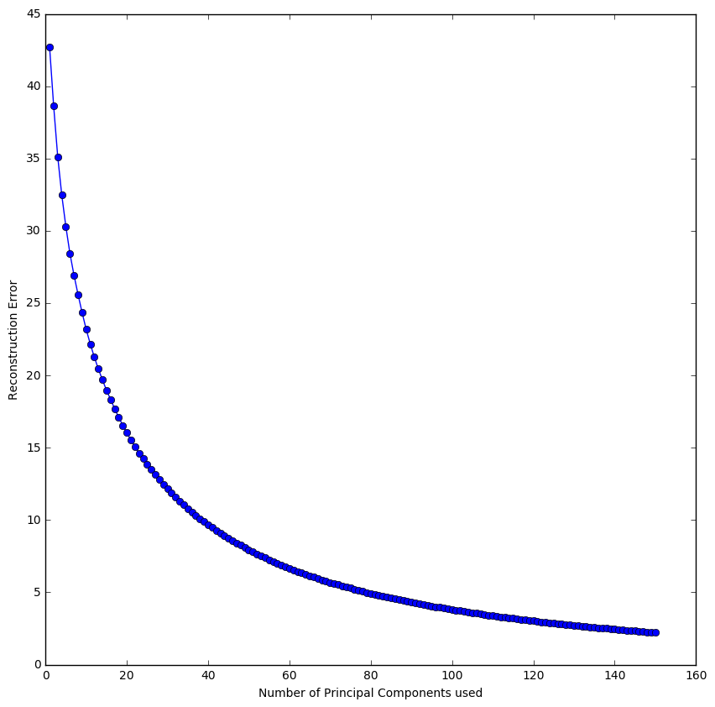

**Plot of Reconstruction Error Vs Number of Principal Components Used**

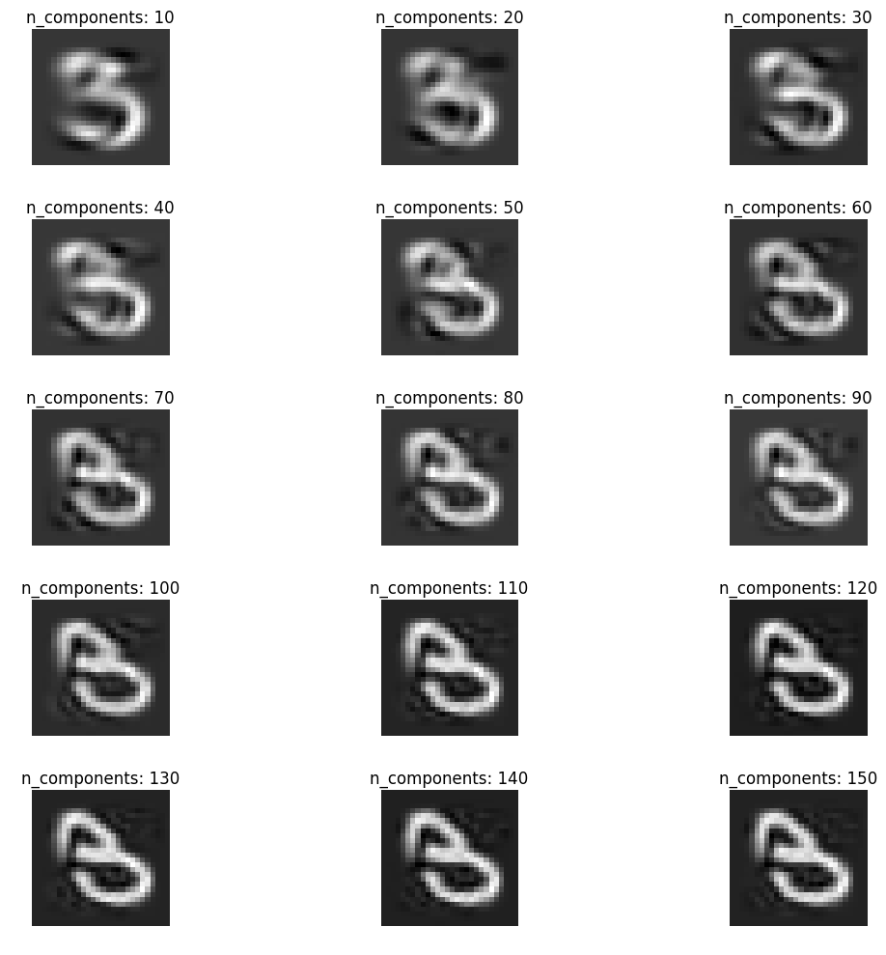

**Visualization of Reconstruction using different number of Principal Components**